Database Design Coursework Template

Student Name: Daniel Georgiev

Student ID:

Student Number: 240015628

Scenario Topic Name Online Video Game Tournament

Scenario (100 words maximum)

The Online Video Game Tournament Platform connects players and teams for tournament competition. Players join a team with their name & email, giving them a unique ID. Their join date will be recorded along with the ID & name of the team they joined. Each team will also have 1 captain. The tournaments that the teams will play in will all have a prize pool with a start & end date and will have to be uniquely identified. Each match in the tournaments will be uniquely identifiable & provide a match date along with the status (scheduled, ongoing, and completed). During each match, certain stats (like kills, deaths, assists, damage dealt, total headshots, total points) will be tracked in real time.

Example queries (Minimum 5 – list, who, which, how many, most, fewest etc. - check that your models have the attributes needed to answer the queries)
- Who is the captain of each team?
- Which players joined more than 1 team?
- How many players joined a specific team after a given date?
- What is the total prize pool of every tournament held?
- How many headshots were recorded by each player in a specific match?
- How many matches are scheduled or ongoing in a specific tournament?
- How many matches took place between given start & end dates of a tournament?
- Which team had the highest prize pool and which team won it?
- How many teams have participated in more than 1 tournament?

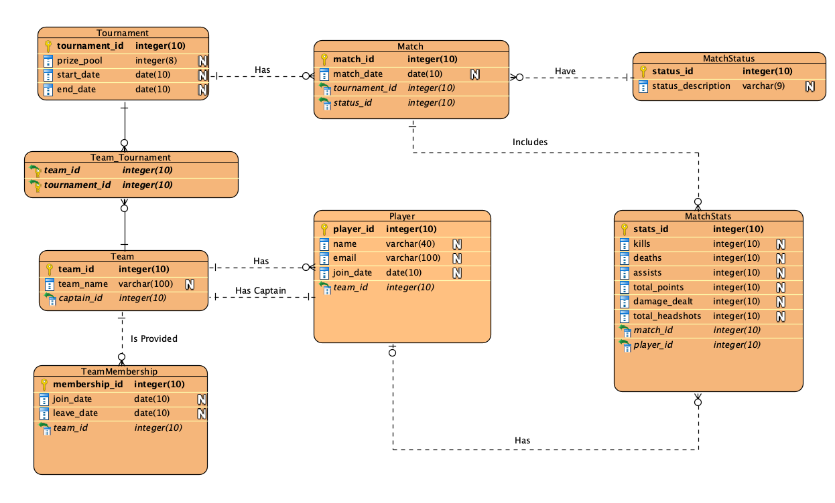
Entity Relationship Model (insert a jpg image of your model exported from Visual Paradigm in the space below).

Relational Model Tables
- Copy and paste the table below for as many relational tables as you need
- Replace the placeholder names (table-name1, attribute-name5 etc) with the table and attribute names you derived from your ER model
- List primary key attributes first
- Add new rows to the tables (in the correct place) as needed
- Delete any unnecessary rows (attribute rows and foreign key rows if not used)
- Primary keys are to be specified in the format PRIMARY KEY (attribute-name1, attribute-name2, etc)
- Foreign keys are to be specified in the format ‘FOREIGN KEY (attribute-name) REFERENCES table-name (attribute-name)

Relational table specification | Marker’s corrections (Do not write in this column)
Table name: Tournament
Attributes
tournament_id
prize_pool
start_date
end_date
PRIMARY KEY (tournament_id)

Relational table specification | Marker’s corrections (Do not write in this column)
Table name: Team
Attributes
team_id
team_name
captain_id
PRIMARY KEY (team_id)
FOREIGN KEY (captain_id) REFERENCES Player(player_id)

Relational table specification | Marker’s corrections (Do not write in this column)
Table name: Team_Tournament
Attributes
team_id
tournament_id
PRIMARY KEY (team_id,tournament_id)
FOREIGN KEY (team_id) REFERENCES Team(team_id)
FOREIGN KEY (tournament_id) REFERENCES Tournament(tournament_id)

Relational table specification | Marker’s corrections (Do not write in this column)
Table name: Player
Attributes
player_id
name
email
join_date
team_id
PRIMARY KEY (player_id)
FOREIGN KEY (team_id) REFERENCES Team(team_id)

Relational table specification | Marker’s corrections (Do not write in this column)
Table name: TeamMembership
Attributes
membership_id
join_date
leave_date
team_id
PRIMARY KEY (membership_id)
FOREIGN KEY (team_id) REFERENCES Team(team_id)

Relational table specification | Marker’s corrections (Do not write in this column)
Table name: Match
Attributes
match_id
match_date
tournament_id
status_id
PRIMARY KEY (match_id)
FOREIGN KEY (tournament_id) REFERENCES Tournament(tournament_id)
FOREIGN KEY (status_id) REFERENCES MatchStatus(status_id)

Relational table specification | Marker’s corrections (Do not write in this column)
Table name: MatchStatus
Attributes
status_id
status_description
PRIMARY KEY (status_id)

Relational table specification | Marker’s corrections (Do not write in this column)
Table name: MatchStats
Attributes
stats_id
kills
deaths
assists
total_points
damage_dealt
total_headshots
match_id
player_id
PRIMARY KEY (stats_id)
FOREIGN KEY (match_id) REFERENCES Match(match_id)
FOREIGN KEY (player_id) REFERENCES Player(player_id)

Insert additional tables here……..

Marker’s Comments (Do not write in this section)

Important: Please note that marker’s corrections to your relational tables are there to help you construct a working database for the second coursework. They are not the determinant of your mark. For more information on how your work is assessed see the coursework specification and grade related criteria.

Coursework Mark (100 marks available):

